Ser No | Title | Name | Designation | Contact  Numbers | Email IDs | Remarks
1 | Dr. | R. Ilavarasan | Assistant Director and Institute-In-Charge | 9444873211 | ar.ilavarasan@ccras.nic.in  arilavarasan@yahoo.co.in
2 | Dr. | S. Chitra | Assistant Director  (Biochemistry) | 9444222950 | s.chitra@ccras.nic.in  chiresh2006@gmail.com | 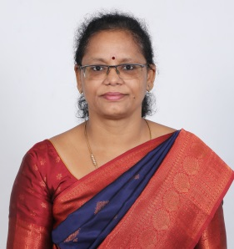
3 | Dr. | G. Kusuma | Research Officer  (Ayurveda) | 9677218572 | kusuma.g@ccras.nic.in  kusumaccras.gmail.com | 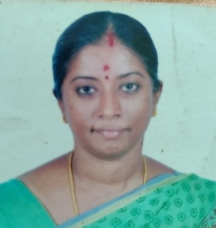
4 | Dr. | R. Arunadevi | Research Officer  (Pharmacology) | 9443654929  7358533939 | arunadevi.r@ccras.nic.in  30aruna@gmail.com | 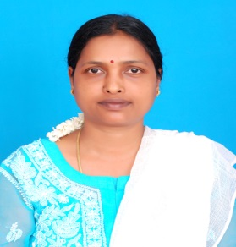
5 | Dr. | G. Nartunai | Research Officer  (Pharmacognosy) | 9894154514 | gnartunai@gmail.com | 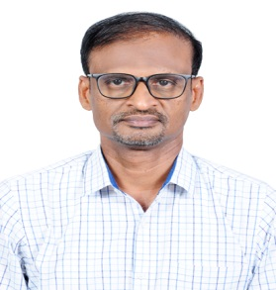
6 | Dr. | Swamy C.T | Research officer  (Microbiology) | 9739113208 | swamy.ct@ccras.nic.in | 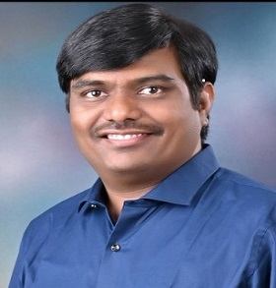
7 | Dr. | Vinod Kumar Thallada | Research Officer  (Chemistry) | 9959265673 | vinod.thallada@ccras.nic.in  vinodthallada@gmail.com | 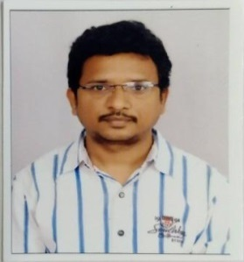
8 | Dr. | Aswathi Mohan P | Research Officer  (Ayurveda) | 9495568215 | achu.mohan@ccras.nic.in  achumohan@gmail.com | 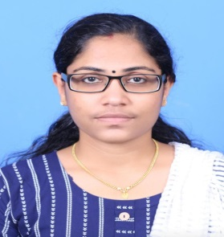
9 | Dr. | Kousik Ghosh | Research Officer  (Chemistry) | 7980454017 | kousikg@ccras.nic.in  kousikghosh1991@gmail.com | 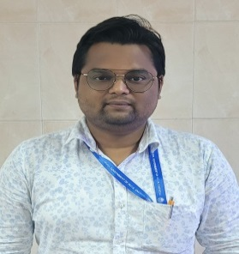
10 | Shri. | C. Prem Kumar | Assistant Research Officer  (Pharmacognosy) | 8754045500 | c.kumarprem@ccras.nic.in  ckumarprem@gmail.com | 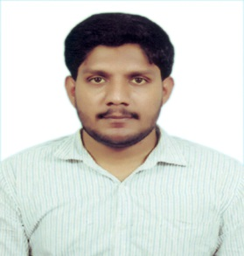
11 | Smt. | M.Thenmozhi | Assistant Research Officer  (Pharmacology) | 9750671768 | thenmozhi.a@ccras.nic.in  thenprabhu2014@gmail.com | 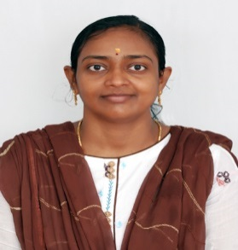
12 | Shri. | M. Prathapa Reddy | Assistant Research Officer  (Chemistry) | 9538543026 | prathapa.nadri@ccras.nic.in  prathapanadri@gmail.com | 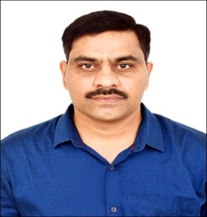
13 | Ms. | N. Monika | Assistant Research Officer  (Pharmacology) | 7358436244 | n.monika@ccras.nic.in  monikanagarajan1@gmail.com | 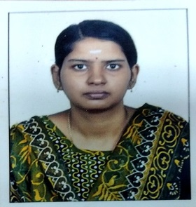
14 | Shri. | Kurra Siva Durga | Assistant Research Officer  (Chemistry) | 8099978784 | k.sivadurga@ccras.nic.in  kurrasivadurga@gmail.com | 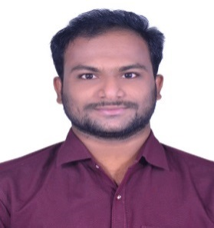
15 | Smt. | K.C. Haritha Yadav | Assistant Research Officer  (Pharmacology) | 9985732306 | kc.haritha@ccras.nic.in  kcharitha9@gmail.com | 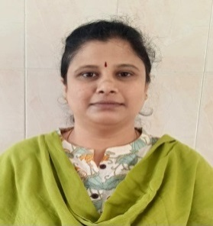
16 | Shri | Ravi Prakash Shaliwal | Assistant Research Officer  (Biotechnology) | 9783107498 | ravi.u2050@gmail.com
18 | Smt | Lakshmi Nair S. | Office Superintendent | 9645200966 | narip.lakshmi@gov.in  lakshmikrishnakumar7477@gmail.com | 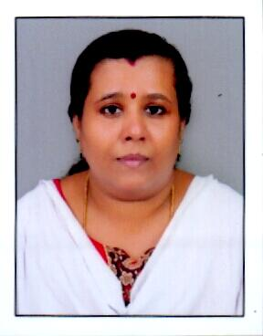
17 | Smt. | E.Nagalakshmi | Stenographer Grade I | 9790710370 | nagalakshmie@ccras.nic.in | 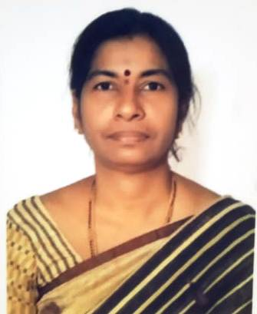  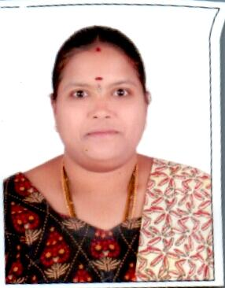
19 | Smt. | B. Radharani | Assistant | 7982935841 | radharani.b@ccras.nic.in
20 | Smt. | B. Maheswari | Research Assistant  (Chemistry) | 9444752626 | magi.vignesh@ccras.nic.in  magivignesh@gmail.com | 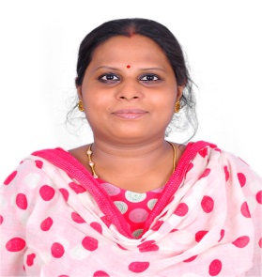
21 | Shri. | V. Naresh | Research Assistant  (Chemistry) | 9618176349 | v.naresh@ccras.nic.in  nareshvelisoju@gmail.com | 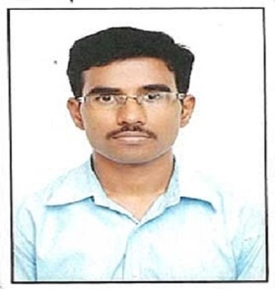
22 | Dr. | Akansha Pandey | Research Assistant  (Botany) | 7376560561 | p.akanksha@ccras.nic.in  akankshap790@gmail.com | 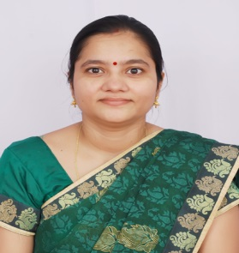
23 | Ms. | Anshu Wali | Research Assistant  (Biochemistry) | 6005135715 | anshuwali@ccras.nic.in  anshu.wali@gmail.com | 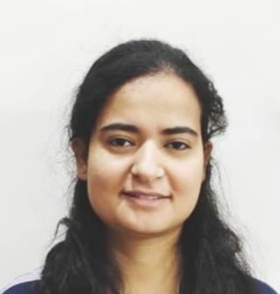
24 | Shri. | J. Sampath Kumar | Upper Division Clerk | 9842915927 | j.sampath@ccras.nic.in | 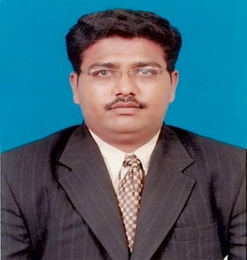
25 | Shri. | Balaji B. | Upper Division Clerk | 8939844099 | balao6army@rediffmail.com | 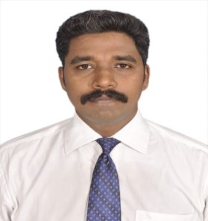
26 | Smt. | C. Shakila | Laboratory Attendant | 7305345765 | c.shakila@ccras.nic.in  thulasishakila@gmail.com | 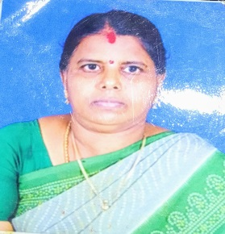
27 | Shri. | R. Raghul Gandhi | Laboratory Attendant | 7358749802 | raghul.gandhi@ccras.nic.in  rraghulgandhi1989@gmail.com | 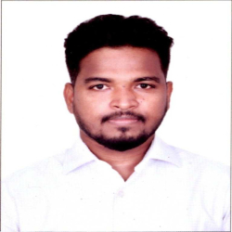
28 | Shri. | S. Ravichandran | Animal Attendant | 9884281707 | ravi.csmcari@ccras.nic.in  ravichandrancsmcari@gmail.com | 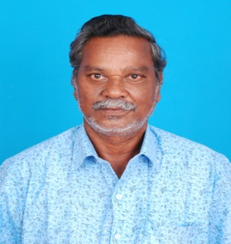
29 | Shri. | R. Loganathan | MTS | 9940382473 | r.loganathan@ccras.nic.in | 