डॉ.अचंट लक्ष्मीपति क्षेत्रीय आयुर्वेद अनुसंधान संस्थान, चेन्नई

Dr. ACHANTA LAKSHMIPATHI REGIONAL AYURVEDA RESEARCH INSTITUTE, CHENNAI

SI. No. | Name | Designation | Contact No. | Email ID | Photo
1 | Dr. T. Maheswar | Assistant Director I/C | 9441415266 | mahesh.rri@ccras.nic.in | 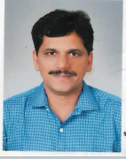
2 | Dr.K. Prameela Devi | Research Officer (Ay.) | 9445812604 | prameela.k.@ccras.nic.in | 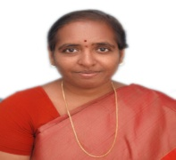
3 | Dr.P. Srinivas | Research Officer (Ay.) | 9840879433 | dr.srinivas.p@ccras.nic.in | 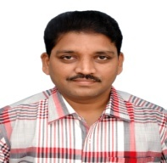
4 | Dr. S. Asha | Research Officer (Ay.) | 9895192067 | asha.s@ccras.nic.in | 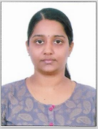
5 | Smt. Rajani Manoj | Assistant | 9495062570 | rajanimanoj2004@gmail.com | 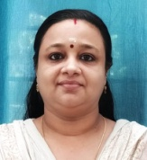
6 | Shri S.Ravinivasan | LDC | 9500055704 | ravi.nivasan93@ccras.nic.in | 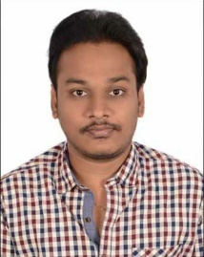
7 | Shri K Balasubramanian | MTS(Attendant) | 7358516706 | bvjybvjy@gmail.com | 