CENTRAL AYURVEDA RESEARCH INSTITUTE
PUNJABI BAGH, NEW DELHI

List of regular Officers & Officials:

S.No. | Name | Designation | Contact No. | Email ID | Photo(If available)
 | Dr. Bharti | Director (Institute) | 9868109737 | drbhartidelhi@gmail.com | 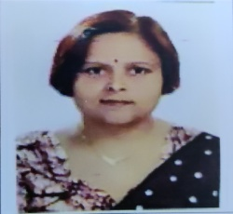
 | Dr Sarada Ota | Assistant Director (Ayurveda) | 9810425662 | sarada_ota@yahoo.com
 | Dr. Renu Makhija | Assistant Director (Path.) | 8368077011 | renu_mkhj@yahoo.co.in | 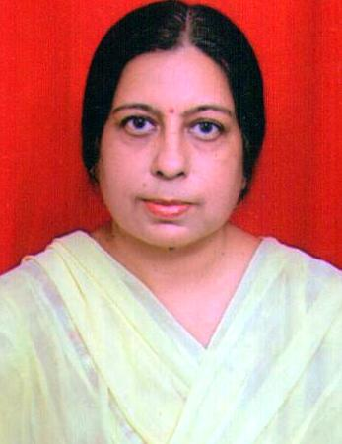
 | Dr. Hemanta Panigrahi | Research Officer (Ayurveda) | 8368351010 | drhemanta71@gmail.com
 | Dr. Sakshi Sharma | Research Officer (Ayurveda) | 9654165662 | drsakshi.sharma87@gmail.com
 | Dr. Seema Jain | Research Officer (Ayurveda) | 9868326045 | dr_seema_jain@yahoo.co.in | 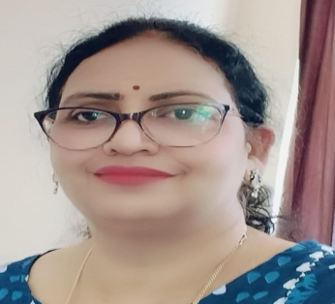
 | Dr. Patel Kishorji Premaji | Research Officer (Ayurveda) | 7405403106 | kishoreworld007@gmail.com | 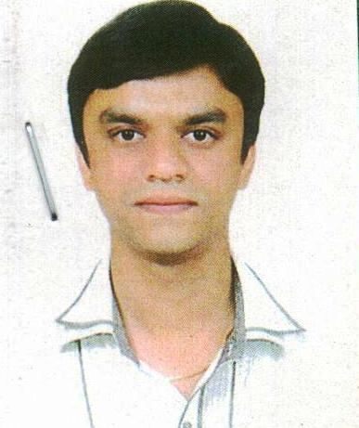
 | Dr. Mata Shweta | Research Officer (Ayurveda) | 8866014946 | drshwetamataccras@gmail.com | 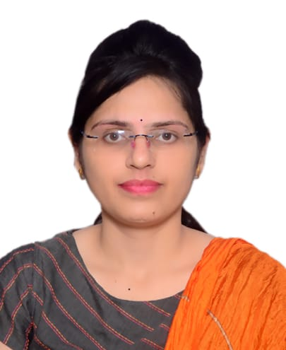
 | Dr. Rajput Shiv Shankar | Research Officer (Ayurveda) | 8200327448 | shivshankerdr@gmail.com | 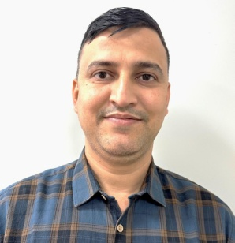
 | Dr. C. Ashwin | Research Officer (Ayurveda) | 9656480129 | ashwinayu@yahoo.in | 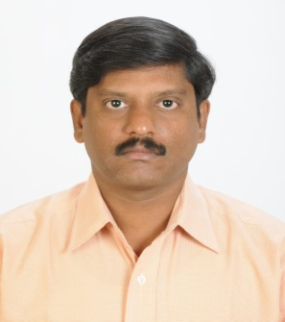
 | Dr. Athira S. | Research Officer (Ayurveda) | 8848220034 | dr.athira84@gmail.com
 | Dr. Anu Bhatnagar | Research Officer (Ayurveda) | 9261606061 | anubhatnagar@ymail.com | 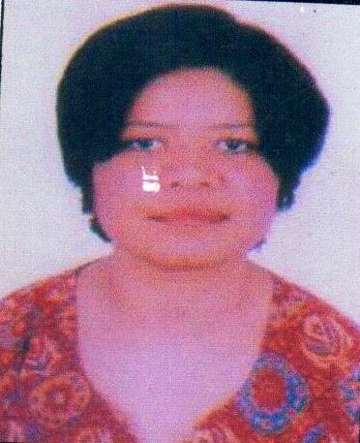
 | Dr. Amit | Research Officer (Ayurveda) | 7988244197 | dr.madan.amit@gmail.com | 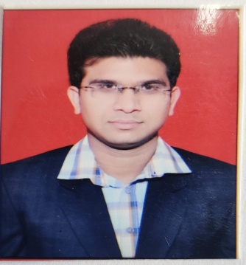
 | Dr. Shaizi Layeeq | Research Officer (Ayurveda) | 8630184149 | drshaizi@gmail.com
 | Dr. Saroj Devi | Research Officer (Ayurveda) | 9882831485 | dr.saroj965@gmail.com
 | Dr. Sudha Kumari Chiluveri | Research Officer (Ayurveda) | 9108175522 | sudha14ayu@gmail.com | 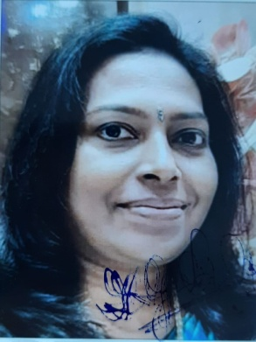
 | Dr. Shweta Chaudhary | Research Officer (Ayurveda) | 7523996565 | drshwetaccras@gmail.com | 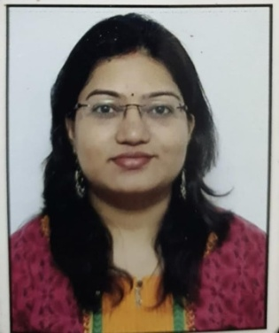
 | Dr. Neha Dubey | Research Officer (Ayurveda) | 9678867770 | ayuneha312@gmail.com
 | Dr. Pramod Chandra Dwivedi | Research Officer (Ayurveda) | 7987035940 | dpramod825@gmail.com | 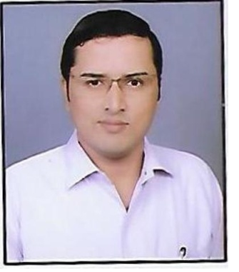
 | Rinky Devi Thakur | Research Officer (Ayurveda) |  | rinky.thakur@gov.in
 | Dr. Renu Rani | Research Officer (Ayurveda) | 9586734447 | Renudhayal09@gmail.com | 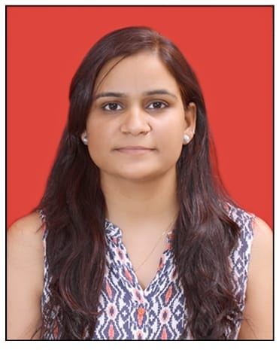
 | Dr. Kuldeep | Research Officer (Ayurveda) | 8954354560 | kuldeepccras@gmail.com | 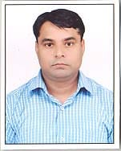
 | Dr. Mayur Surana | Research Officer (Ayurveda) | 9503504200 | mayursrn@gmail.com
 | Dr Sharwan Kumar Sahu | Research Officer (Ayurveda) | 7500799915 | drsahu79@gmail.com
 | Dr. Ashima Jain | Research Officer  (Path.) | 8971121641 | drashimajain2112@gmail.com | 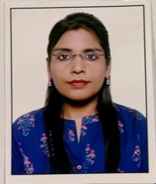
 | Ms. Moutusi Biswas | Assistant Matron | 9051122310 | moutusi1976@gmail.com | 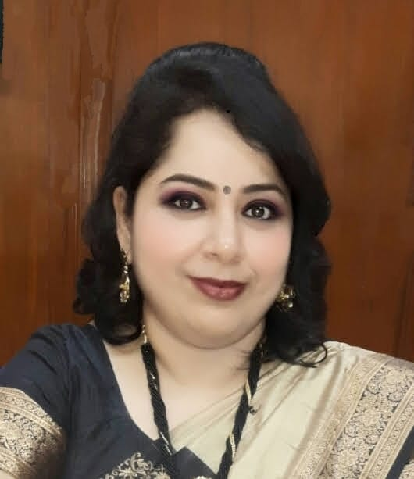
 | Ms. Aastha Dawar | Assistant Research Officer (Clinical Psychology) | 8447248646 | aasthadawar@rediffmail.com | 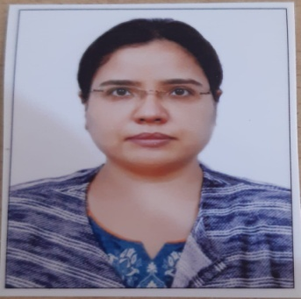
 | Ms. Disha Garg | Assistant Research Officer  (Phsysiotherapy) | 9654754095 | physioarodisha21@gmail.com | 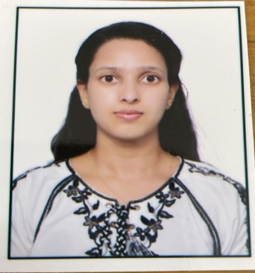
 | Smt. Sonali Sharma | Hindi Translator (Hindi Assistant) | 9821278330 | sonsharma1994@gmail.com
 | Ms. Shweta Chaudhary | Staff Nurse | 8766290717 | shwetaneww@gmail.com | 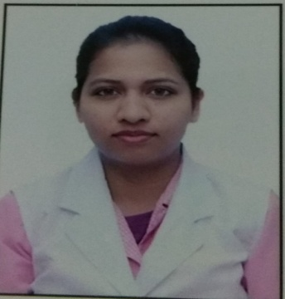
 | Smt. Priya Chugh | Staff Nurse | 9910892550 | priyachugh2525@gmail.com | 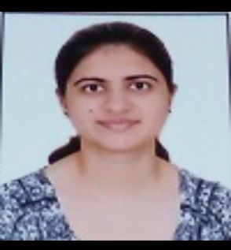
 | Ms. Akansha Sharma | Staff Nurse | 9968797229 | aakusharma66@gmail.com | 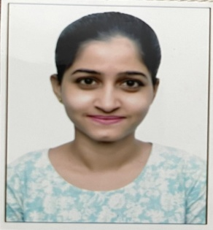
 | Smt Ekta | Staff Nurse | 8191042396 | ekta28111996@gmail.com | 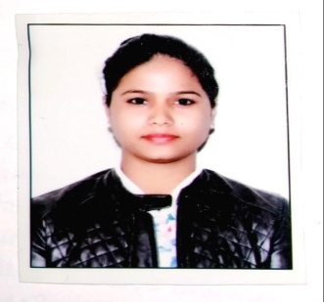
 | Smt Arannya Mukhjree | Staff Nurse | 9038723618 | mukherjeearannya4@gmail.com | 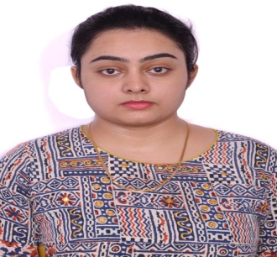
 | Ms. Monu Sharma | Staff Nurse | 7073265506 | sharmashubham8706@gmail.com | 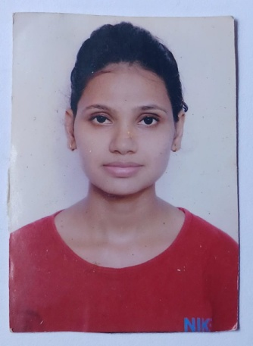
 | Sh Munesh | Staff Nurse | 9414843557 | sattavan44@gmail.com | 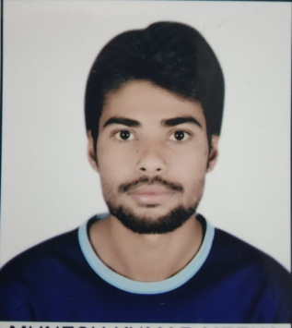
 | Sh. Pramod Kumar | Pharmacist (Ayurveda) | 9911478786 | pramod_jha127@yahoo.com | 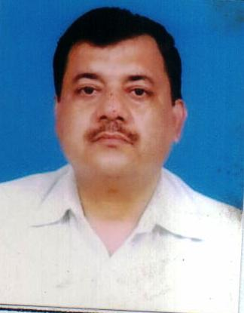
 | Sh. Baccharaj Kumhar | Pharmacist  (Ayurveda) | 9660246763 | bachharajkumhar@gmail.com | 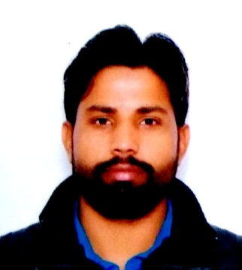
 | Sh. Gorav | Pharmacist  (Ayurveda) | 7984770263 | nagargorav@gmail.com | 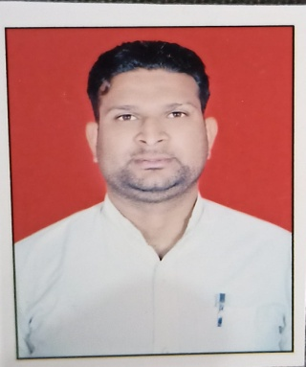
 | Sh. Manish Kumar | Pharmacist  (Ayurveda) | 8104257639 | Manish.bhh@gmail.com | 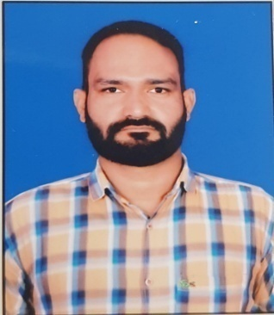
 | Sh Veerendra Gupta | Pharmacist  (Ayurveda) | 9621408249 | veerendragupta07@gmail.com | 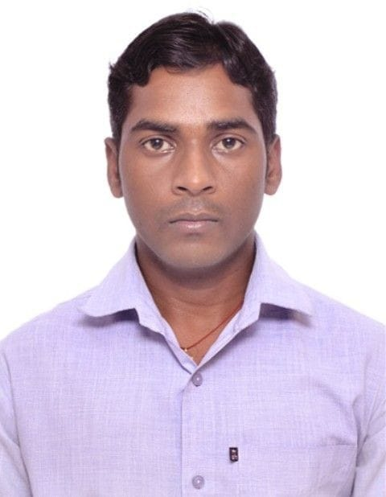
 | Sh Rajnath Rawat | Assistant | 9868116069 | rawatrajnath@gmail.com
 | Sh. Mukesh | Assistant | 9932397605 | mbalmiki853@gmail.com
 | Sh. V.S. Pandey | Laboratory Technician (Path) | 8587043343 | vspandeylab@gmail.com
 | Sh. Nempal Singh | Laboratory Technician (Path) | 9911190377 | nempal43@gmail.com | 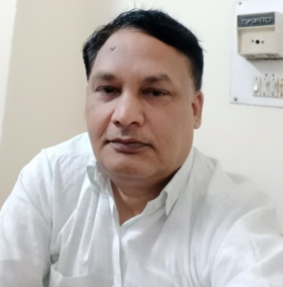
 | Sh. Abhishek Gautam | Laboratory Technician (Path) | 784088889898 | abhi.gautam.ag@gmail.com | 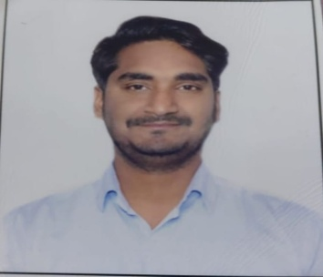
 | Sh Lakhmi Chand Yadav | Laboratory Technician (Path) | 9691255216 | luckyyadav256@gmail.com | 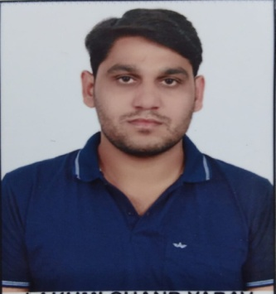
 | Sh. Ankit Thakran | Upper Division Clerk | 8377875526 | thakran1231@gmail.com
 | Smt Sweta Bhardwaj | Dark Room Assistant | 9643198638 | bhardwajsweta9@gmail.com
 | Sh. Sunil Kumar | Driver | 9211386941 | Savitasingh53668@gmail.com | 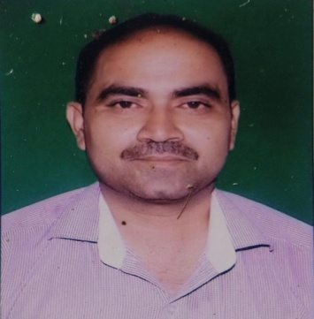
 | Sh. Himanshu | Lower Division Clerk | 9015758764 | himanshuacri@gmail.com | 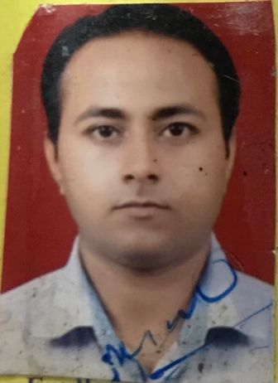
 | Sh Sonu | Lower Division Clerk | 9971025868 | Sy65057@gmail.com
 | Sh. Surender Mohan Sihara | Laboratory Attendant (Path.) | 9476298369 | meenasms85@gmail.com | 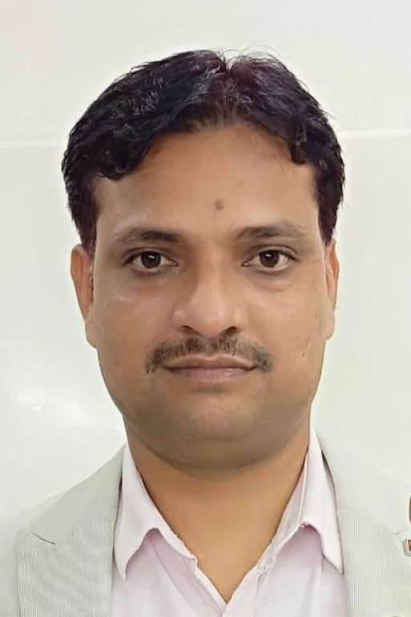
 | Sh. Amit | Laboratory Attendant (Path.) | 8178252725 | Amitbana1581986@gmail.com | 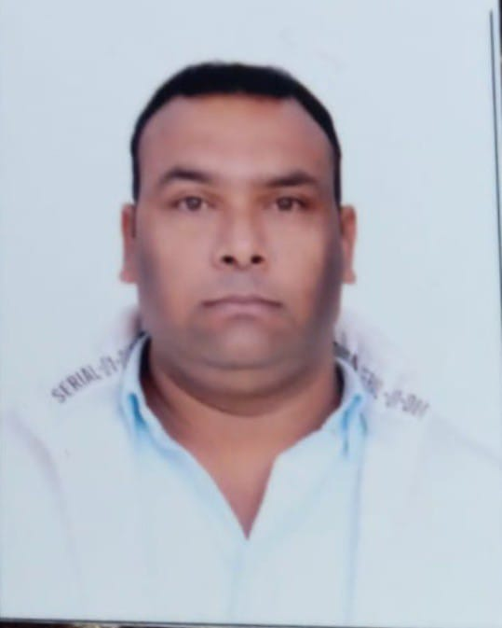
 | Sh. Anil Kumar | M.T.S | 9015673537 | Anilkumar886050@gmail.com | 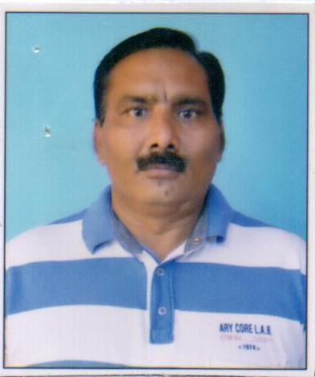
 | Sh Bhupender Singh | Laboratory Attendant (Path.) | 9560841925 | bhupenders671@gmail.com | 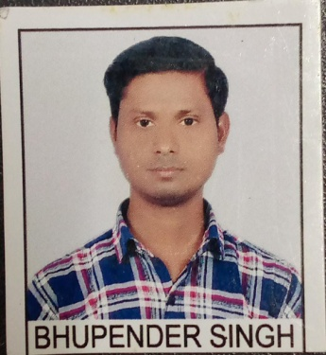
 | Sh Dhanesh | M.T.S | 7643060813 | Vk1189991@gmail.com | 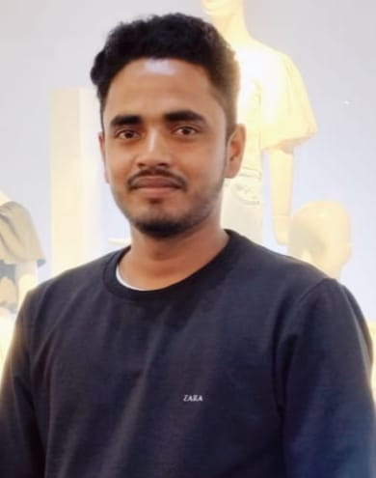
 | Smt. P. Kalawathy | Panchkarma Attendant | 9716127521 | Venkateshlalu96@gmail.com | 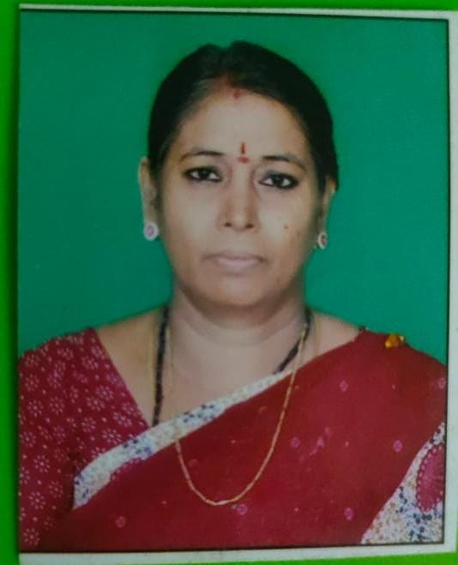
 | Smt. Roopa | M.T.S | 9599763981 | Roopakumari1981@gmail.com | 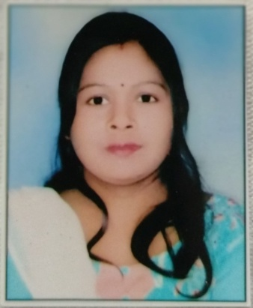
 | Sh Kumar Vivek | M.T.S | 8340156478 | vivek1234.1003@yahoo.in | 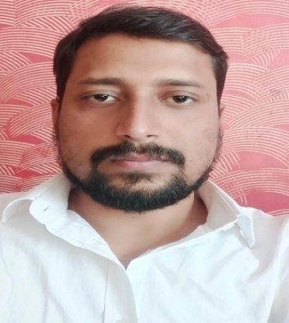
 | Sh Bharat Kumar Sharma | M.T.S | 8527722753 | bharat10699kumar@gmail.com | 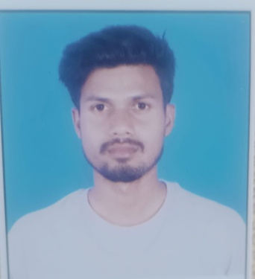
 | Sh Sagar | M.T.S | 7303812252 | singhsagar445@gmail.com
 | Sh. Desh Raj Singh | M.T.S |  |  | 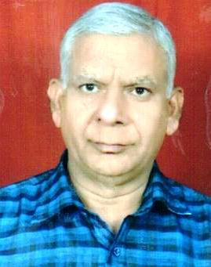
 | Sh. Kirodh Kumar | M.T.S | 8979520838 |  | 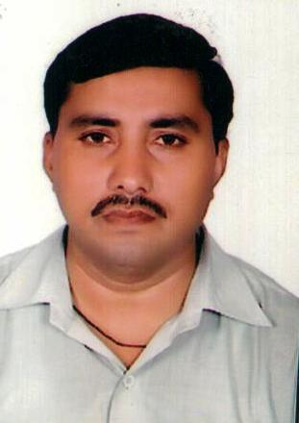
 | Sh. Krishna Gopal | M.T.S | 9871392120 | Krishnagopal2208@gmail.com | 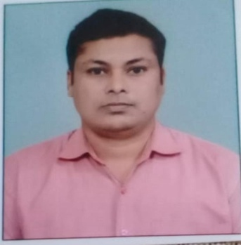
 | Sh. Ravinder | M.T.S | 9650031884 | Ravindermathur99@gmail.com | 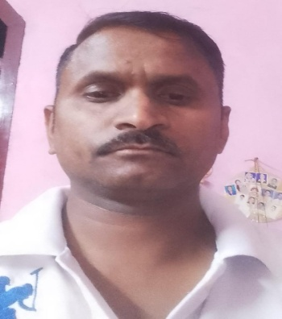
 | Sh. Bhim Sen | M.T.S | 8851713171 | bhimsen698@gmail.com | 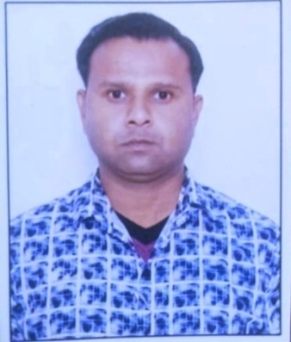
 | Sh Deepak Chauhan | M.T.S | 9027274335 | Dc250611@gmail.com | 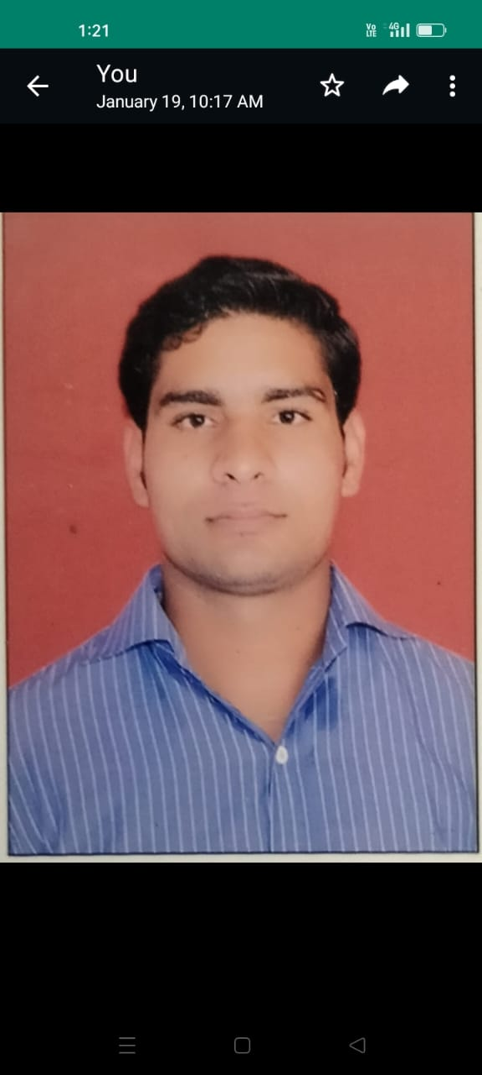
 | Sh Manjeet | M.T.S | 8571880945 | Manjeetkalaramna2829@gmail.com | 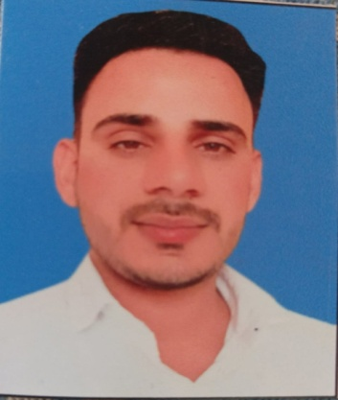
 | Sh Shiv Raj Meena | M.T.S | 9887163417 | shivrajsahriya@gmail.com | 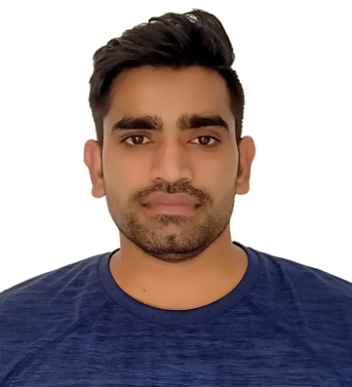
 | Sh Aman | M.T.S | 9315167054 | Amanbohat2@gmail.com | 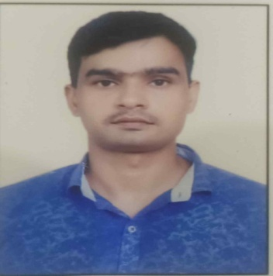
 | Sh. Om Prakash | M.T.S | 8285756762 | Omprakashdwivedi1010@gmail.com | 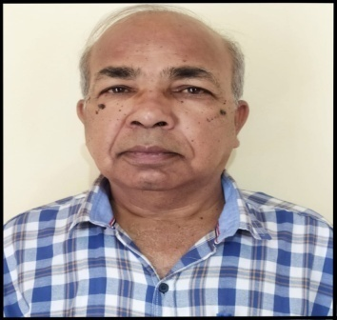
 | Sh. Dharmveer Singh | M.T.S | 9278014644 | summykumar77@gmail.com | 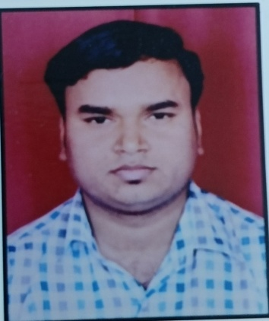
 | Sh. Rahul | M.T.S | 9999067453 | Rahulacri1993@gmail.com | 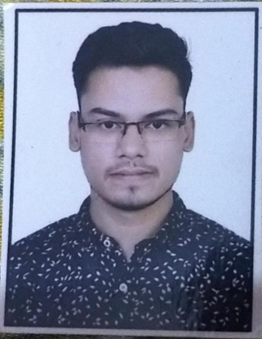
 | Sh. Nagendra | M.T.S | 9958796674 | Nagenderrawat22@gmail.com | 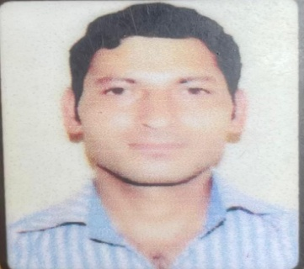
 | Sh. Sunil | M.T.S | 8851707347 | Sunilcari1988@gmail.com | 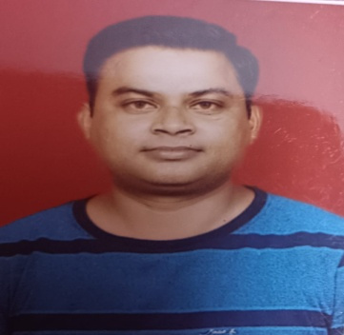
 | Sh. Raghubir Singh | M.T.S | 9968887343 | raghubirrawat@gmail.com | 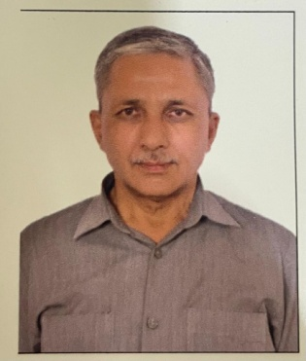
 | Sh. Amit Dhiman | M.T.S | 9999114827 | Amit.kr.dhiman01@gmail.com | 