Regional Ayurveda Research Institute, Aamkho, Gwalior-474009 (M. P.)
S.No. | Name | Designation | Contact No. | E-Mail Id | Photo  (If available)
 | Dr. Ajay Kumar Meena | Assistant Director (Chemistry) & Institute In-Charge | 8076510154  9958525231 | ajaysheera@gmail.com  ajay.meena@gov.in | 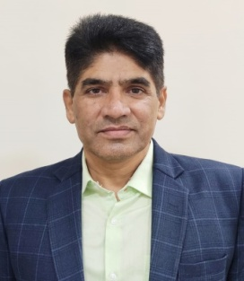
 | Dr. B. S. Sisodia | Assistant Director (Bio-Chemistry) | 9619621766 | brijeshgwl@gmail.com  bs.sisodia@nic.in | 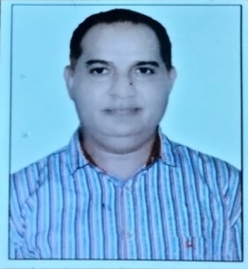
 | Dr. Savita Sharma | Assistant Director (Ayurveda) | 8149526366 | savitashirish@yahoo.co.in | 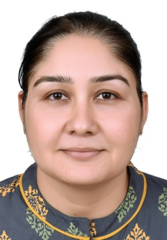
 | Dr. M.M. Sharma | Research Officer (Ay.) | 9810691874 | mmsharmajpr@gmail.com  dr.mmsharma@gov.in | 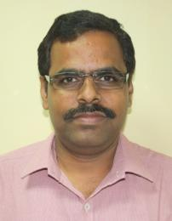
 | Dr. Anil Mangal | Research Officer (Ay.) | 9755412502 | dranilmangal1@gmail.com | 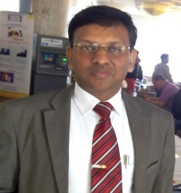
 | Dr. BhavanaShrivastava | Research Officer (Chem.) | 7999890963 | bhavanakam@gmail.com | 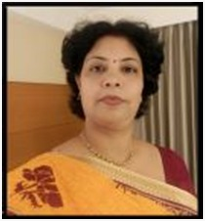
 | Smt. S. A. Kondalkar | Research Officer (Pharmacog.) | 9926999761 | sapna.soni@rediffmail.com | 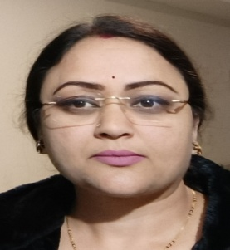
 | Dr. S.B.Singh | Research Officer (Ay.) | 9782560296 | dr.shyam84@yahoo.in | 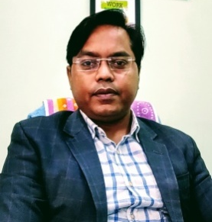
 | Dr. Amit Kumar | Research Officer (Ay.) | 7018706270 | amitnegiayurveda@gmail.com | 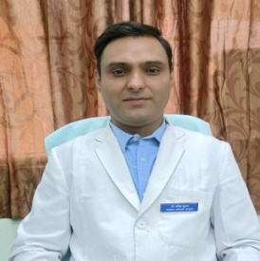
 | Dr. Surendra Kumar, | Research Officer (Ay.) | 7048108355 | drsurendra87@gmail.com | 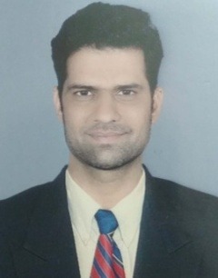
 | Dr. Srikala V. | Research Officer (Ay.) | 8547900265 | sreev89@gmail.com | 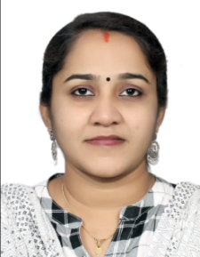
 | Dr. Jeevan K. | Research Officer,  Animal Experimental Pathology | 8660580015 | jeevan.k@ccras.nic.in  jeevank1116@gmail.com | 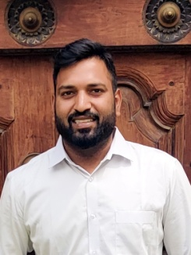
 | Dr. AllakondaLingesh | Research Officer (Animal Pathology) | 9032304269 | Allakonda.l@ccras.nic.in  Lingeshallakonda@gmail.com | 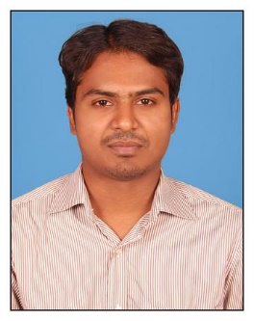
 | Sh. RudramaniTiwari | Assistant Research Officer | 8103313550 | tiwarirudramani9@gmail.com | 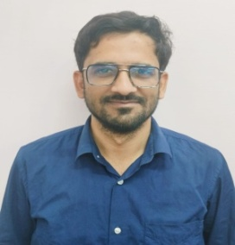
 | Sh. Hariom | Sister In-charge | 9425717672 | hariomlodhi1577@gmail.com | 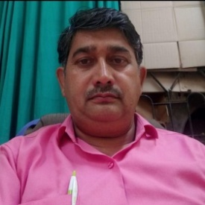
 | Sh. TribhuvanNath | Pharmacist | 9425775652 | nathtribhuban43@gmail.com | 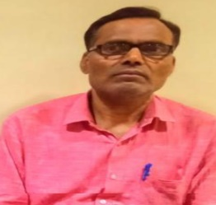
 | Sh. Shaitana Ram | Staff Nurse | 8290225688 | bhagwatibmr92@gmail.com | 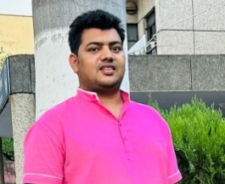
 | Sh. Sudheer Singh Shekhawat | Staff Nurse | 7239963678 | sudhirrajputmmmmmmm@gmail.com | 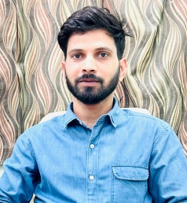
 | Sh. DharmveerBairwa | Staff Nurse | 8890774419 | dhveer664@gmail.com | 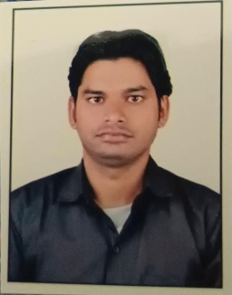
 | Sh. Om prakash Saharan | Staff Nurse | 9672728610 | opsaharan21@gmail.com | 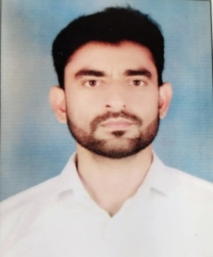
 | Ku. Anshika Ravi Verma | R.A. (Bio-Chemistry) | 9978603780 | anshikarverma5@gmail.com  anshika.verma@ccras.nic.in | 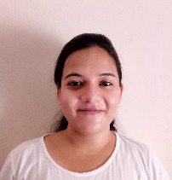
 | Dr. Om Prakash, | R.A. (Chemistry) | 7417504014 | ompchausali@gmail.com | 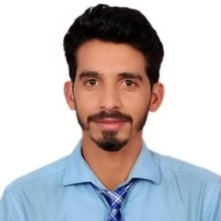
 | Sh. Vivek Kumar | RA (Chemistry) | 9911087087 | vivek.kr.1494@gmail.com | 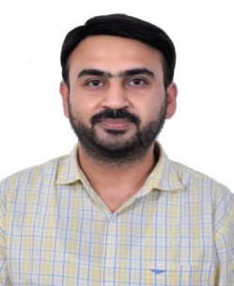
 | Smt. VandanaBharti | R.A. (Chemistry) | 9179075837 | bharathi.vandana@gmail.com | 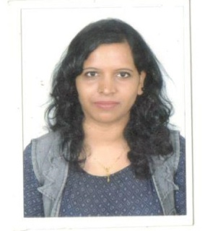
 | Sh. Biswajit Paul | R.A. (Botany) | 9563361598 | bpaul8293@gmail.com
 | Dr. Chandra Shekhar Sharma | R.A. (Chemistry) | 9555404317 | shekharsbhu@gmail.com | 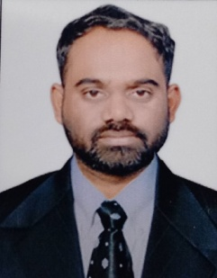
 | Sh. Braj Mohan Meena | Lab. Asstt. | 9098646351 | brajmohanrekha@gmail.com | 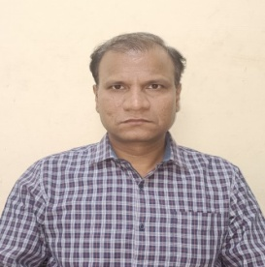
 | Sh. Lav Kush Sharma | Lab. Atted. | 9806903855 | luvkushsharma@hotmail.com | 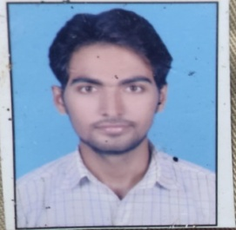
 | Sh. Shyam Kant Sharma | Lab. Atted. | 9479310012 | shyamkantsharma48@gmail.com | 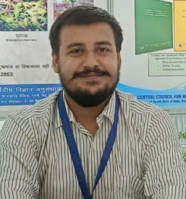
 | Sh. Vikash Mishra | Lab Atted. | 8654987535 | vikasmishra354@gmail.com | 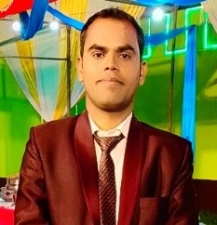
 | Sh. Deepak Goud | M.T.S. | 9039886560  7999782582 | dkgond476@gmail.com | 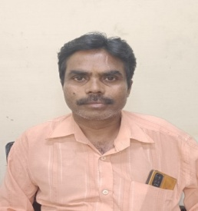
 | Sh. R.B. Godiya | M.T.S. | 6263163433 | rambabucri2018@gmail.com | 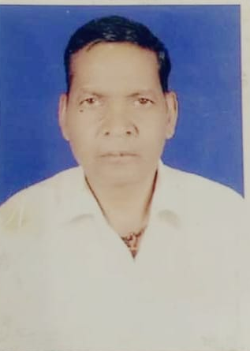
 | Sh. S.K. Joshi | M.T.S. | 8889022995 |  | 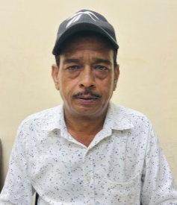
 | Smt. Sharda Sharma | M.T.S. | 7354635500 |  | 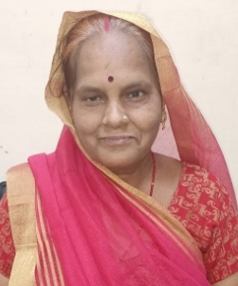
 | Sh. R.S. Gour | M.T.S. | 7000554535 | rameshgaur0077@gmail.com | 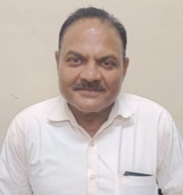
 | Sh. ArvindPippal | M.T.S. | 9984202775 | apippal79@gmail.com | 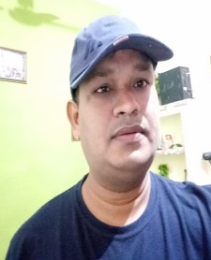
 | Sh. Rohit | M.T.S. | 7470313072 | godiya541995rock@gmail.com | 