S.No | Name | Designation | Contact No | Email ID | Photo (If available)
1 | Dr. Rajesh Sannd | Assistant Director In-charge | 9316223524 | sandrajesh@yahoo.com | 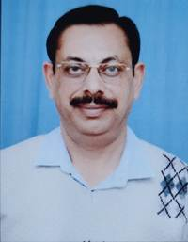
2 | Dr. Vineeta Kumari Negi | Research Officer (Ayu.) | 9805147033 | drvineetanegi@gmail.com | 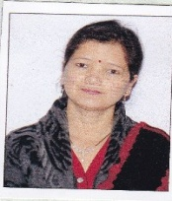
3 | Dr. Vikas Nariyal | Research Officer (Ayu.) | 9103649609 | Vikas.nariyal@gov.in | 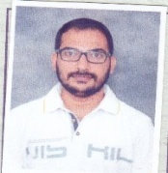
4. | Dr. Kavita Mansukhbhai Vyas | Research Officer (Ayu.) | 9888552911 | kavitakrishu@gmail.com | 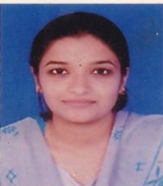
5. | Dr. Anubha Chandla | Research Officer (Ayu.) | 7009591103 | dranubhachandla@gmail.com | 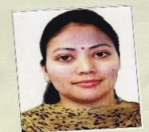
6. | Sh. Manoj Raturi | Assistant Research Officer (Bot.) | 9411558084 | Manojraturi987@gmail.com | 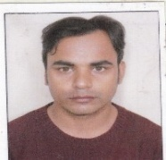
7. | Smt Pallavi Sharma | Sister –in-charge | 9418165213 | pallavisharmamnd@gmail.com | 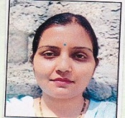
8 | Sh. Devrajan Dariya | Staff Nurse | 9887600472 | devrajandariya@gmail.com | 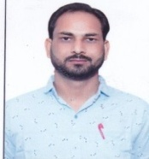
9. | Sh. Jagdev Chand | Pharmacist | 7807564182 | Jagdevlucky87@gmail.com | 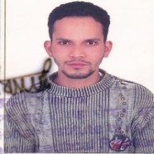
10 | Sh Hardeep Singh | Research Assistant (Bot.) | 8493844008 | Hari01015@gmail.com | 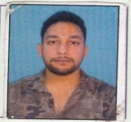
11. | Sh. Pushpendra Kumar Jatav | Pharmacist | 9024114149 | Kpushpendra786@gmail.com | 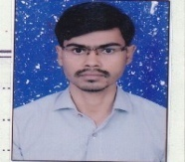
12. | Sh Vishal Kailey | Lower Division Clerk | 7973706715 | Vishalkailey966@gmail.com | 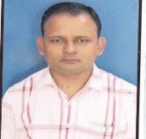
13 | Smt Sita Devi | Lower Division Clerk | 7018022054 | Sitadevi22054@gmail.com | 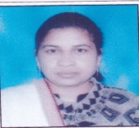
14. | Sh. Dalip Singh | Lab Attandent | 8219115591 | Dalipsingh0389@gmail.com | 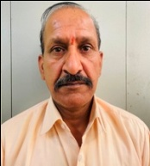
15 | Smt Kalpna Devi | Lab Attendant | 9882835604 | kalpnadhiman06@gmail.com | 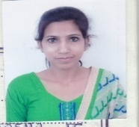
16. | Sh. Surendra Singh | MTS | 9805463662 | Surenders11078@gmail.com | 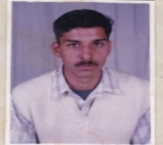
17 | Sh. Rinku | MTS | 8580703772 | Rinkurana22121997@gmail.com | 