क्षेत्रीय आयुर्वेद अनुसंधान संस्थान, कोथरुड पुणे
Regional Ayurveda Research Institute, Kothrud Pune
Sr. No. | Name | Designation | Contact No. | Email ID | Photo (If Available)
 | Dr. Arun Manohar Gurav | Research Officer Incharge | 7588025784 | arun.gurav@ccras.nic.in | 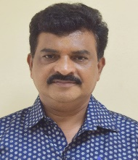
 | Dr. Manish Motiram Wanjari | Research Officer | 9229205231 | wanjari.manish@ccras.nic.in | 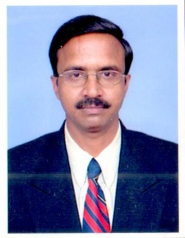
 | Dr. Shrirang Balkrishna Jamadagani | Research Officer | 9038008005 | s.jamadagani@ccras.nic.in | 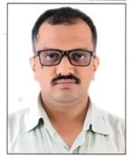
 | Dr. Pallavi Shrirang Jamadagni | Research Officer | 9007210251 | p.jamadagani@ccras.nic.in | 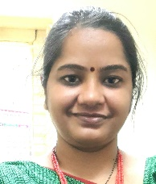
 | Dr. M. Srinivasan | Research Officer | 8891174459 | s.marimuthu@ccras.nic.in | 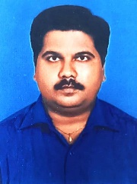
 | Dr. Gajanan Pawar | Research Officer | 8424868979 | gajanan.powar81@gov.in | 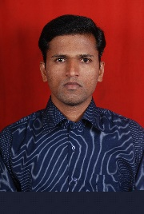
 | Dr. Rasika Hemchandara Kolhe | Research Officer | 9582977118 | rasika.kolhe@ccras.nic.in | 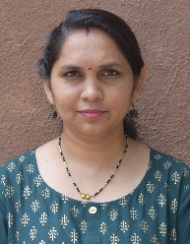
 | Miss. Prachika | Assistant Research Officer | 7709053157 | prachika.kr@ccras.nic.in | 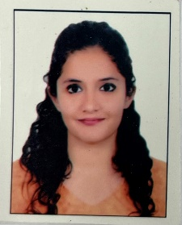
 | Mr. Tamboli Munaf Ayub | Assistant Research Officer | 8330903452 | munaf.tamboli@ccras.nic.in | 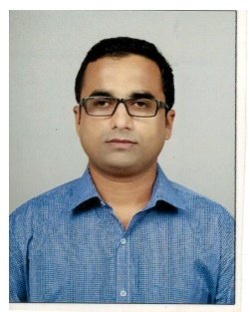
 | Dr. Nalban Nasiruddin | Assistant Research Officer | 9453612075 | nasiruddin@ccras.nic.in | 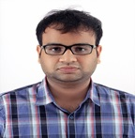
 | Dr. Anurag Kumar | Assistant Research Officer | 9527851025 | anurag.kumar@ccras.nic.in | 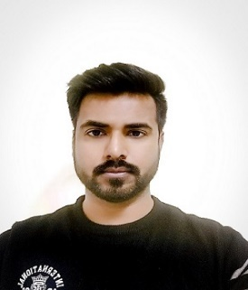
 | Dr. Sudhir Digambar Matte | Assistant Research Officer | 9410323039 | sudhir.m@ccras.nic.in | 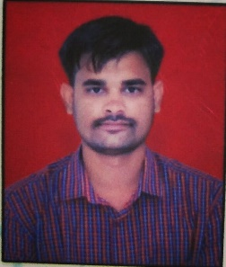
 | Dr. Prem Prakash Jangid | Research Assistant | 7980132570 | pp.jangid@ccras.nic.in | 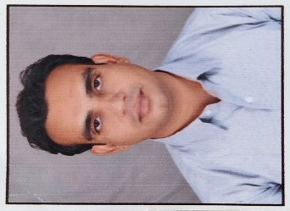
 | Mr. Barun Santra | Research Assistant | 9850890511 | barun.santra@ccras.nic.in | 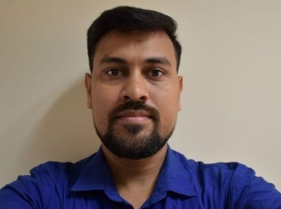
 | Mrs. Archana Girish Mhase | Herbarium Assistant | 9822776450 | gm.archana@ccras.nic.in | 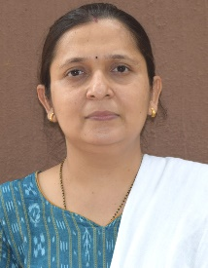
 | Mr.Deelip N. Sonkambale | Field Collector | 9822479059 | d.sonkamble@ccras.nic.in | 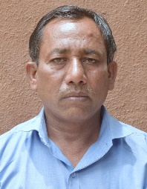
 | Mr. Pravin Maruti Londhe | Grade I – Driver | 8424868979 | londhe.pravin@ccras.nic.in | 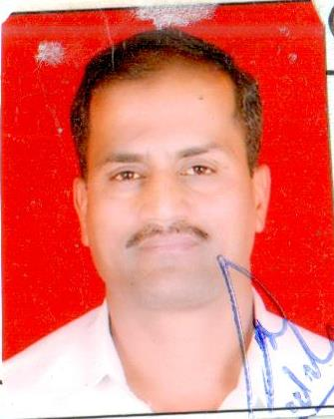
 | Mr. Suresh Koli | UDC | 8605232953 | Suresh.koli@ccras.nic.in | 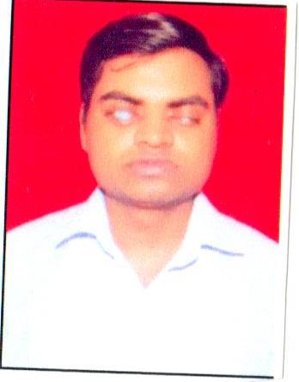
 | Mr. Lalit Ishwarlal Sarse | MTS | 9579692307 | lalit.sarse@ccras.nic.in | 