Name of the Institute- RARI, Vijayawada

S.No. | Name | Designation | Contact No. | Email ID | Photo(If available)
 | Dr.C. Murali Krishna | Research Officer Incharge(Ay.) | 9492030564 | mkchagamreddy@gmail.com | 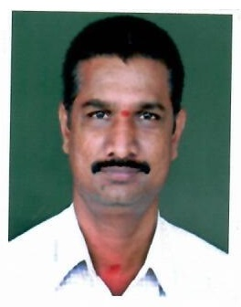
 | Dr. A.J.V Sai Prasad | Research Officer(Ay.) | 9490716761 | saipranatiavvaru@gmail.com | 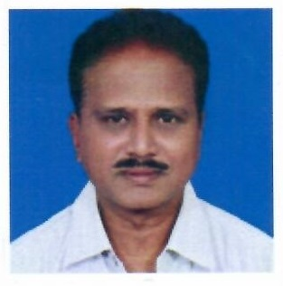
 | Dr. Sujata P.Dhoke | Research Officer(Ay.) | 7016289621 | sujubasic@gmail.com | 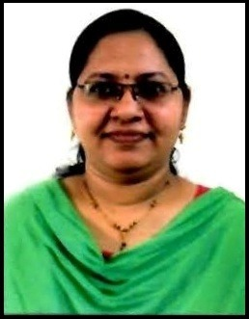
 | Dr. K. Midhuna Mohan | Research Officer(Ay.) | 8639006068 | midhunamohan@gmail.com | 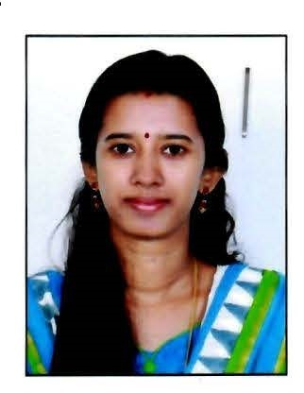
 | Dr.Savita Poshatti Gopod | Research Officer(Ay.) | 9177777631 | Savitagopod18@gmail.com | 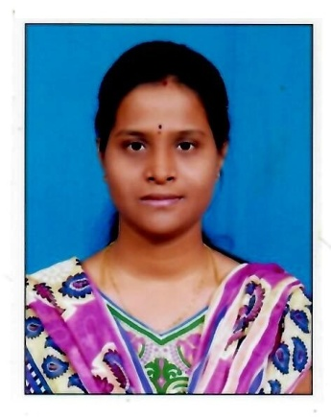
 | Dr.K.Anumol | Research Officer(Ay.) | 8075021635 | dranumolk@gmail.com | 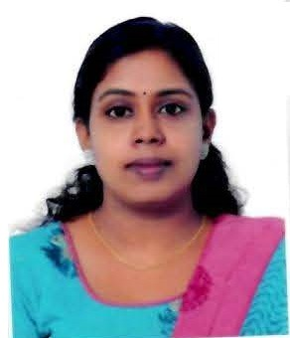
 | Dr. K. Nishanth | Research Officer(Ay.) | 9946307403 | dr.nishanth.k@gmail.com | 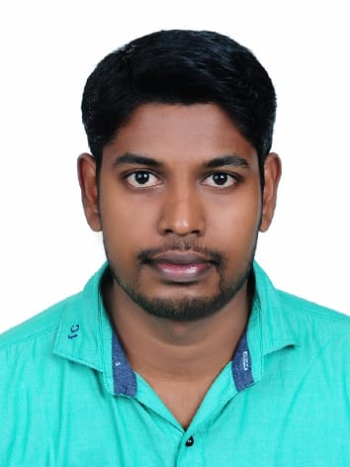
 | Smt.V.Neelima | Assistant | 9032911892 | neelima.narivbd@gmail.com | 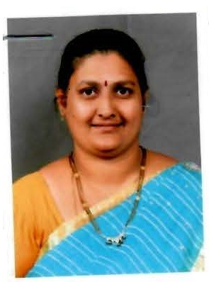
 | Sri.Dinesh Cherukuri | Staff Nurse | 9849421381 | dinesh.c@ccras.nic.in | 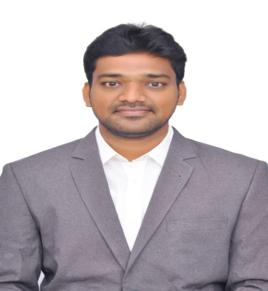
 | Smt.P.Rajya Lakshmi | Staff Nurse | 9010869601 | rajyalaxmipasupuleti@gmail.com | 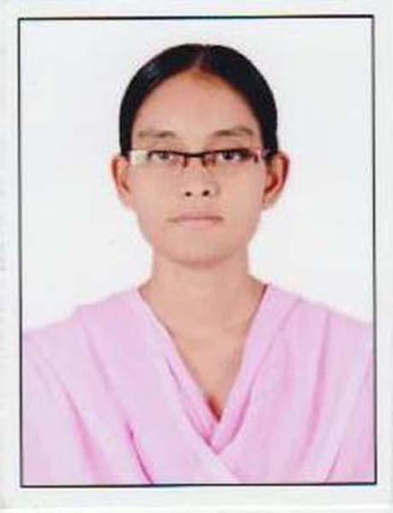
 | Sri Prince Kumar Pal | Pharmacist | 9456410346 | prince87imsbhu@gmail.com | 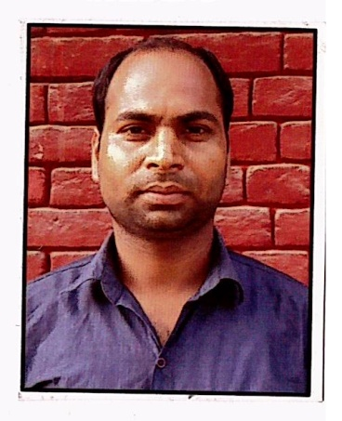
 | Sri Neeraj Jain | Pharmacist | 8104495605 | neeraj1101jain@gmail.com | 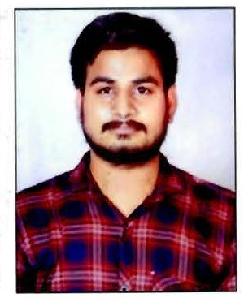
 | Sri CH.Somaiah | Lab Technician | 9701270142 | somuchella@gmail.com | 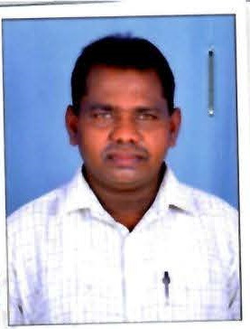
 | Sri. T.Mahammad Ghouse | Lab Technician | 7892182958 | ghousetm@gmail.com | 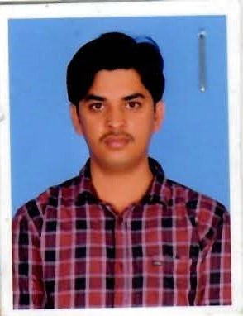
 | Sri.K.Lakshmi Narayana | Lab Technician | 9030560550 | kln781@gmail.com | 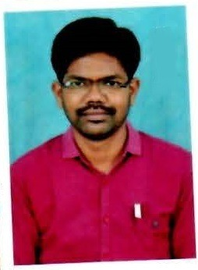
 | Sri.P.Vinod Kumar | Lab Attendant | 9398021365 | panditkumar75@gmail.com | 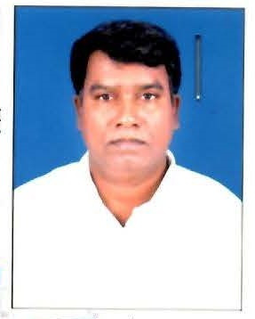
 | Sri.M.Visweshwara Rajesh | Dark Room Assistant | 9533845459 | rajehotone@gmail.com | 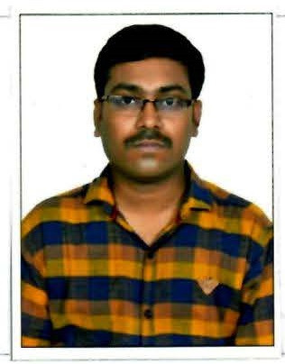
 | Sh. CH. Shankar | Lab Attendant | 8074296550 | shankar.ch567@gmail.com | 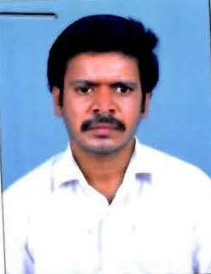
 | Sh. Ch. Shiva Prasad | Lab Attendant | 9032222777 | spchowdary72@gmail.com | 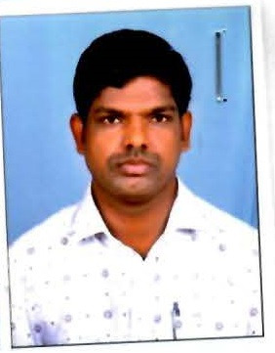
 | Sri.A.Kiran Kumar | M.T.S. (Peon) | 9705690016 | dheeranaruri@gmail.com | 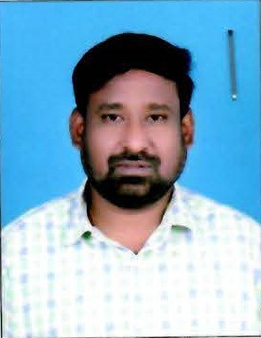
 | Sri.D.B.V.Ramana | M.T.S. (Chowkidar) | 9346484976 | venkataramanadarsi322@gmail.com | 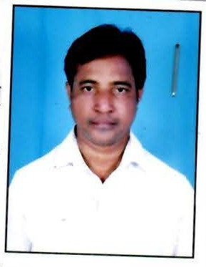
 | Smt.A.Mangamani | M.T.S. | 9494715404 | -- | 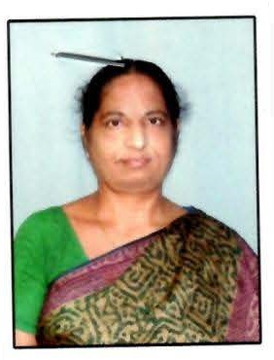
 | Sri.K.Srikanth | M.T.S. | 9959107280 | ksrikanth3328@gmail.com | 