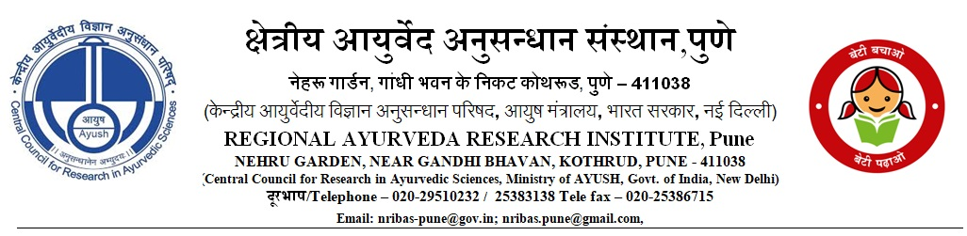
Pune-ADM/1/2025-TECH/ABIHR/ 864 Dt. 14.08.2026
Walk in Interview
Walk in interview for the two Project Technical Support-II positions under ABIHR project “Preclinical Toxicological Evaluation and Safety Pharmacology of selected Ayurvedic Formulations-Laksha Guggulu, Dadimadi Ghrita and Ekangaveera Rasa” will be held on following Schedue at Regional Ayurveda Research Institute, Kothrud, Pune - 411 038 (M.S.). Selection procedure will comprise of a written test followed by interview of the written test qualified candidates, on the same day. The details of qualification and experience are as under.

Sl. No. | Name and number of the Post | Essential Qualification, Experience & Age | Remuneration | Date and time of Interview
2. | Project Technical Support II  Numebr of posts: 02 | B.Sc (with biology/ biotechnology/microbiology)/ B. Pharm + 2 years’ relevant laboratory experience Maximum Age limit: 30 years | Rs. 20,000 per month plus 30% HRA | 24/08/2026  at 10.00 am

General Conditions:
- Age will be determined as on 01/08/2026. Age relaxation will be given to SC/ST/OBC candidates as per Govt. Rules.
- Duration of the project is three years.
- The engagement will be purely temporary on contract basis and initially for a period of six months which is extendable to next six months’ subject to performance of the candidate. No claim for continuation or regular appointment will be entertained.
- Applicants should bring their original certificates of educational qualification and experience, proof of age, etc with a set of photocopies and two passport size photographs.
- No TA/DA will be paid for attending the written test/Interview.

-Sd-
(Dr. Arun Gurav)
Head of the Institute and Research Officer

